مافي ملاحظات على المحاضرة رقم 12

# 1.3 How to Install Packages

Install.package(“name”)

* Note: if u did not type a name, R will let u choose one of the available packages.

Remove.pachage(“name”)

And every time u need to use an installed package u need to use *library(name)*

# 1.4 Customizing The Look of R Studio

There is no thing to commit in fact

# 15. Apply Function in R



U can reach the properties of the apply function from R but take this example.

Ex.

> stockData = read.csv("Notes/StockExample.csv", header = T, row.names = 1)

> apply(X= stockData,MARGIN = 2,FUN = mean )

Stock1 Stock2 Stock3 Stock4

163.746 NA 1523.000 91.571

> apply(X= stockData,MARGIN = 2,FUN = mean , na.rm=T)

Stock1 Stock2 Stock3 Stock4

163.746000 1.463333 1523.000000 91.571000

N0TE: u don’t need to type (X, MARGIN, FUN... etc.) if u are typing the default order.

* U can use cloMeans() to do the job as well.
* And the same case with rows 🡪 rowMeans.

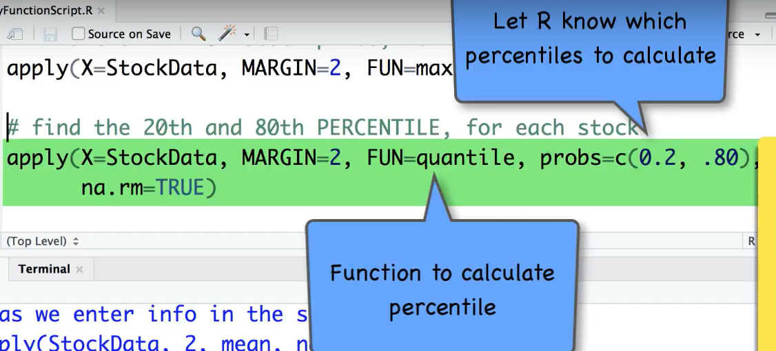

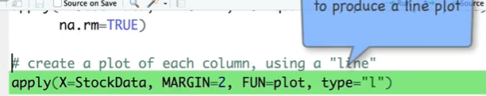

# 1.6 apply Function



* Most of the comments can be found in tApplyFunctionScript.R.

